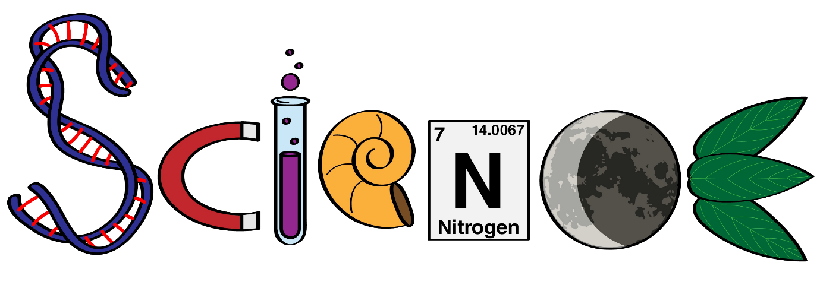

Our Science principles mean we aim to help children…

- Participate in lessons that are practical and inspiring.

- Be inquisitive and ask questions in order to deepen their knowledge of the world around them.

- Develop and use scientific vocabulary accurately and appropriately.

- Obtain knowledge that can be applied to the world they live in.

- Learn about scientists who have shaped our world.
